[15 points total] An ACK scan does not provide information about whether a target machine’s ports are open or closed, but rather whether or not access to those ports is being blocked by a firewall. If there is no response or an ICMP “destination unreachable” packet is received as a response, then the port is blocked by a firewall. If the scanned port replies with a RST packet, that means the ACK packet reached its intended host. So the target port is not being filtered by a firewall. Note, however, even though ICMP went through, the port itself may be open or closed.
Describe at least 2 rules that could be used by Snort to detect an ACK scan. Clearly express your assumptions and explain your rules. Do you think Bro can do a better job of detecting an ACK scan?

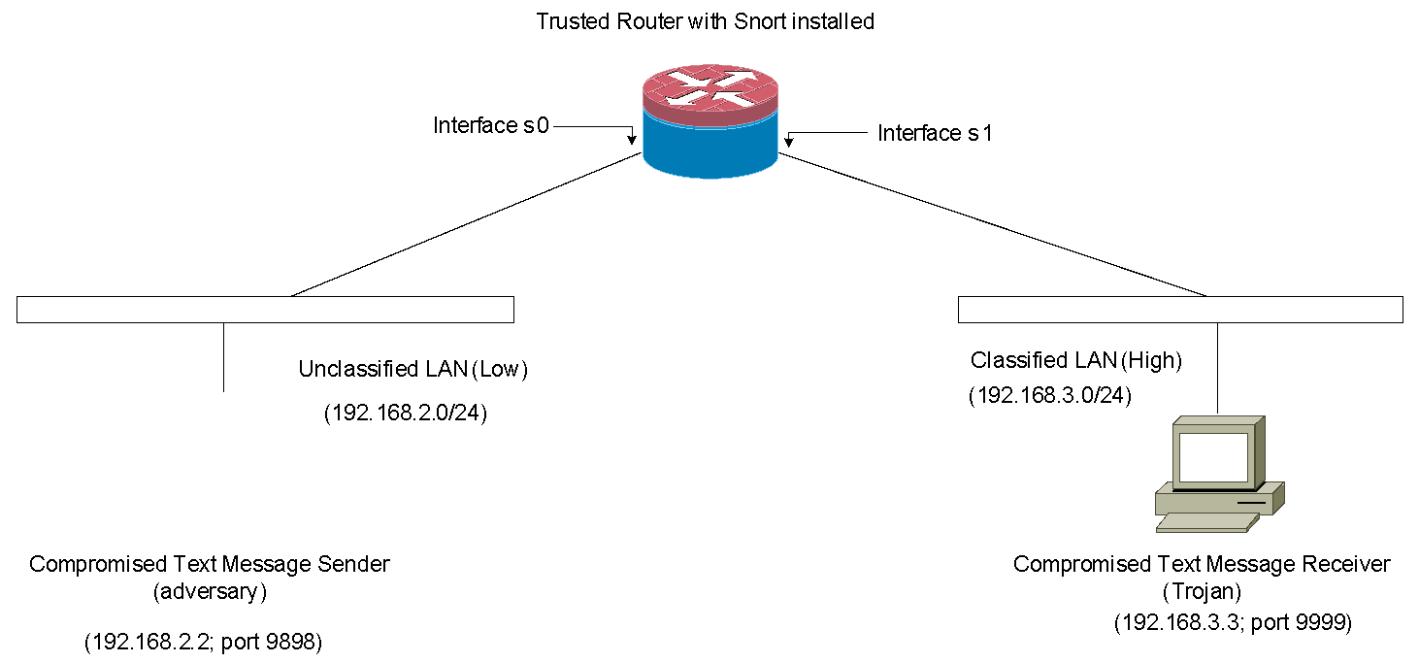
[Part A 15 points, Part B 9 points, 24 points total] As shown in the above diagram, Kevin, the system admin, installed a text-message sender and a text-message receiver in a Multi-Level-Secure (MLS) environment. In the MLS environment, two security levels exist (i.e., Unclassified (Low) and Classified (High) levels). His goal is to enforce the Bell-LaPadula (BLP) access control model in the network. Essentially, the BLP model defines two mandatory access control rules:
- No Read Up Rule: a subject (Low) at a lower security level must not read an object (High) at a higher security level. Simply, a Low entity cannot have read-access to a High object.
- No Write Down Rule: a subject (High) at a higher security level must not write to any object (Low) at a lower security level. Simply, a High entity cannot have a write-access to a Low object.
In this scenario, enforcing the BLP model means no confidential information flows from Classified LAN (High) to Unclassified LAN (Low). However, information can still flow from Unclassified LAN to Classified LAN.
To achieve his goal, he configured both text message sender and receiver as follows:
- The text message sender is configured to send a text message to the text message receiver via TCP/IP protocol.
- The text message receiver is configured to receive a simple text message from the sender via TCP/IP protocol.
- The following IP/port is given to each machine:
  - Text message sender: 192.168.2.2 and port 9898 is open
  - Text message receiver: 192.168.3.3 and port 9999 is open
  - A text message is allowed to be sent only from port 9898 of 192.168.2.2 (sender) host to port 9999 of 192.168.3.3 (receiver) host.
Part A) As you can see from the diagram above, the text message sender and receiver have been compromised by the adversary and the Trojan, respectively. However, the router with Snort IDS installed (router/snort) is securely protected and can be fully trusted.
Write efficient Snort rules and access control lists which will be implemented on the router/snort to detect or block confidential information leakage from High to Low. Write your rationale for writing your rules and access control lists. For example, if the text message receiver (Trojan at High LAN) attempts to send a text message (confidential information) to the text message sender (the adversary at Low LAN), the attempt will be either blocked by your access control list(s) or detected by your snort rule(s).
Write at least 3 Snort rules and at least 2 access control lists (ACLs). Please note that each rule and ACL must have a complete a detailed rationale. If possible, you must submit screen pictures of the output of the Snort compilation to confirm that your Snort rules are written correctly using the Lab #2 software. [15 points]
Hint: Access control lists are discussed in Module 10 and snort rules are covered in Module 7 as well as Lab2. To see more snort options, please refer to chapter 3 of Snort User Manual 2.9.1 by the Snort Project (link: http://www.snort.org/assets/166/snort_manual.pdf)
Answer:
Part B) Describe a way for the Trojan to covertly transmit 4 characters (e.g., A, B, C and D) to the adversary without being detected or blocked by your rules and access control lists provided in Part A. [8 points]

